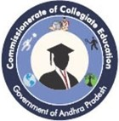
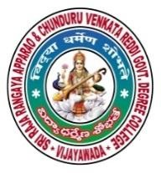
SRR & CVR GOVERNMENT DEGREE COLLEGE
(AUTONOMOUS)
VIJAYAWADA, KRISHAN DIST., A.P
NAAC B+GRADE(CGPA:2.60)

IN ASSOCIATION WITH RED ROPE

REPORT OF
INCLUSIVE CENTRE EVENT
LIVE JAM

DATE: 29-10-22

LIVE JAM
FfIAMUNIQUE - 2022

About LiveJam

Our vision is the transformation of urban youth through music and media.

OBJECTIVE OF THE PROGRAMME

- An initiative to inspire young adults with positive values about identity and hope
- To provide emotional support and value-based skills & tools to urban youth struggling with these issues
- To provide tools to colleges, schools, teachers & mentors who can engage youth with the emotional support they need

Outcome: To motivate and engage youth in an offline a ctivity that reminds them about their unique identity and personal capacity to overcome failures, negative emotions, and destructive habits

Activity
This is a 20-minute activity that teachers and student representatives conducted with students during a free/recess time.
Steps and instructions given below:
The posters placed at prominent notice boards/ soft boards where the student community is able to view and engage with it with ease.
Students follow the instructions provided on the poster to:
Completed the words using the jumbled letters
Placed their thumbprints on the dotted line across the’=’ sign
The completed words are: BRAVE, ORIGINAL, LOVED and DARING. After this, students will notice/should be pointed out a fifth hidden word: BOLD (which reads vertically on the poster, using the first letter of each of the above words).
After students have marked their thumbprints across the ‘=’ sign, the message that emerges is:
MY FAILURES ARE NOT EQUAL TO MY FUTURE.
This activity showed on the notice board.
Key points of learning
Each thumbprint is unique to an individual. Even if an individual tries to imitate or mimic or copy a friend or doubts their self-worth, they are uniquely and wonderfully created gifted individuals. There is no one else like them.
The failures and mistakes of their past do not define them or their future. They have the capacity to overcome especially when they exercise the opportunity to make better choices.

The poster is offered for youth to help them deal with personal emotional distress and motivate them to take practical positive steps towards change. Live Jam believes that the activity will partner with your efforts to nurture youth under our care.

ACTIVITY CONDUCTED BY THE STUDENT ON 29-10-2022

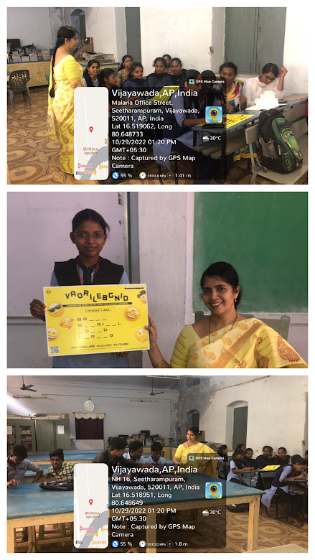

DISPLAYED ON NOTICE BOARD

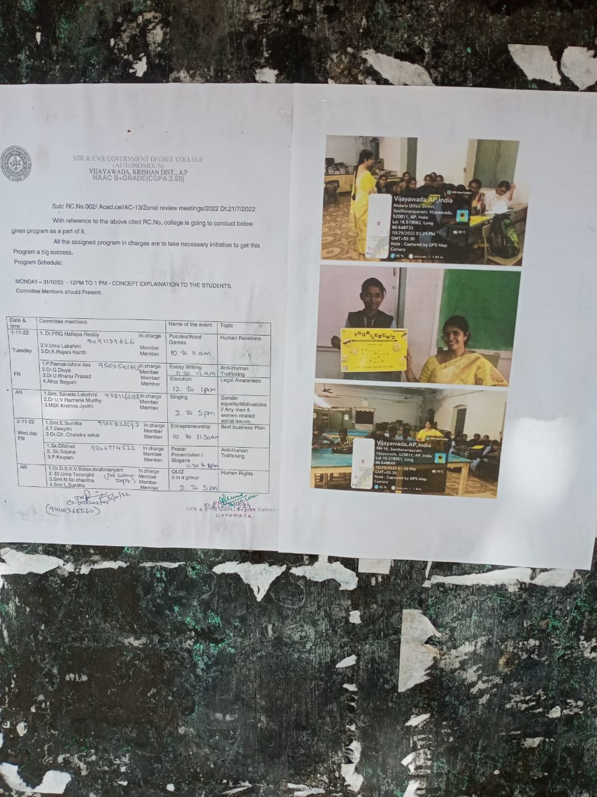

FEEDBACK OF THE STUDENTS:
Students said this event got fun and confidence in them.
Participated actively and enjoyed the activity.

